**THE 8051 ARCHITECTURE**

**Features of 8051 Microcontroller**

* + Eight bit CPU
  + On chip clock oscillator
  + 4Kbytes of internal program memory (code memory) [ROM]
  + 128 bytes of internal data memory [RAM]
  + 64 Kbytes of external program memory address space.
  + 64 Kbytes of external data memory address space.
  + 32 bidirectional I/O lines (can be used as four 8 bit ports or 32 individually addressable I/O lines)
  + Two 16 Bit Timer/Counter :T0, T1
  + Full Duplex serial data receiver/transmitter
  + Five vector interrupt structure (RESET not considered as an interrupt.)
  + ALU can perform arithmetic and logic functions on 8 bit variables.
  + Four Register banks with 8 registers in each bank.
  + Sixteen bit Program counter (PC) and a Data pointer (DPTR)
  + 8 Bit Program Status Word (PSW)
  + 8 Bit Stack Pointer

**Comparison between 8051 Family Members**

* The following table compares the features available in 8051, 8052, and 8031.

|  |  |  |  |
| --- | --- | --- | --- |
| **Feature** | **8051** | **8052** | **8031** |
| ROM(Bytes) | 4k | 8k | 0k |
| RAM (Bytes) | 128 | 256 | 128 |
| Timers | 2 | 3 | 2 |
| I/O | 32 | 32 | 32 |
| Serial Ports | 1 | 1 | 1 |
| Interrupt Sources | 6 | 8 | 6 |

**Block Diagram of 8051 Microcontroller:**

* **CPU (Central Processing Unit)**:
* It is the heart of the Microcontroller that mainly comprises of an Arithmetic Logic Unit (ALU) and a Control Unit (CU) and other important components. The CPU is the primary device in communicating with peripheral devices like Memory, Input and Output.
* ALU or Arithmetic Logic Unit, as the name suggests, performs the Arithmetical and Logical Operations. CU or Control Unit is responsible for timing of the communication process between the CPU and its peripherals.
* **Oscillator:** As the microcontroller is digital circuit therefore it needs timer for their operation. To perform timer operation inside microcontroller it required externally connected or on-chip oscillator. The 8051 has On-Chip crystal oscillator of 12MHz.
* **Interrupt control:** Interrupt control is used to handle interrupt request that is coming from different input sources. The 8051 has five interrupts.
* Timer 0 overflow interrupt - TF0
* Timer 1 overflow interrupt - TF1
* External hardware interrupt - INT0
* External hardware interrupt - INT1
* Serial communication interrupt - RI/TI
* **Program Memory:** The instructions of the CPU are stored in the Program Memory. It is usually implemented as Read Only Memory or ROM, where the Program written in to it will be retained even when the power is down or the system is reset.
* **Data Memory:** Data Memory in a Microcontroller is responsible for storing values of variables, temporary data, intermediate results and other data for proper operation of the program.Data Memory is often called as RAM (Random Access Memory), which is a type of volatile memory. It is generally organized as registers and includes both Special Function Registers (SFRs) and user accessible memory locations.
* **Bus**: Bus is a group of wires which uses as a communication control or acts as means of data transfer. The two types of bus used in 8051 microcontroller:
* **Address Bus**: 8051 microcontrollers is consisting of 16 bit address bus.
* **Data bus**: 8051 microcontroller is consisting of 8 bits data bus.
* **Input/output Ports –** The 8051 Microcontroller needs to be connected to the peripheral devices in order to control their operations. The I/O Ports are responsible for the connection of the Microcontroller to its peripheral devices. There are total Four 8-bit Input/output Ports present in this Microcontroller.

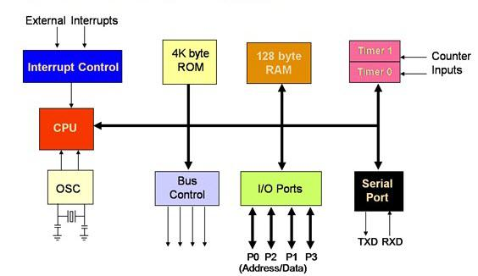

**THE 8051 PIN DIAGRAM**

* The 8051 microcontroller is a 40 pin Dual Inline Package (DIP). The 8051 has four I/O ports where in each port has 8 pins which can be configured as input or output depending upon the logic state of the pins. Therefore, 32 out of these 40 pins are dedicated to I/O ports.

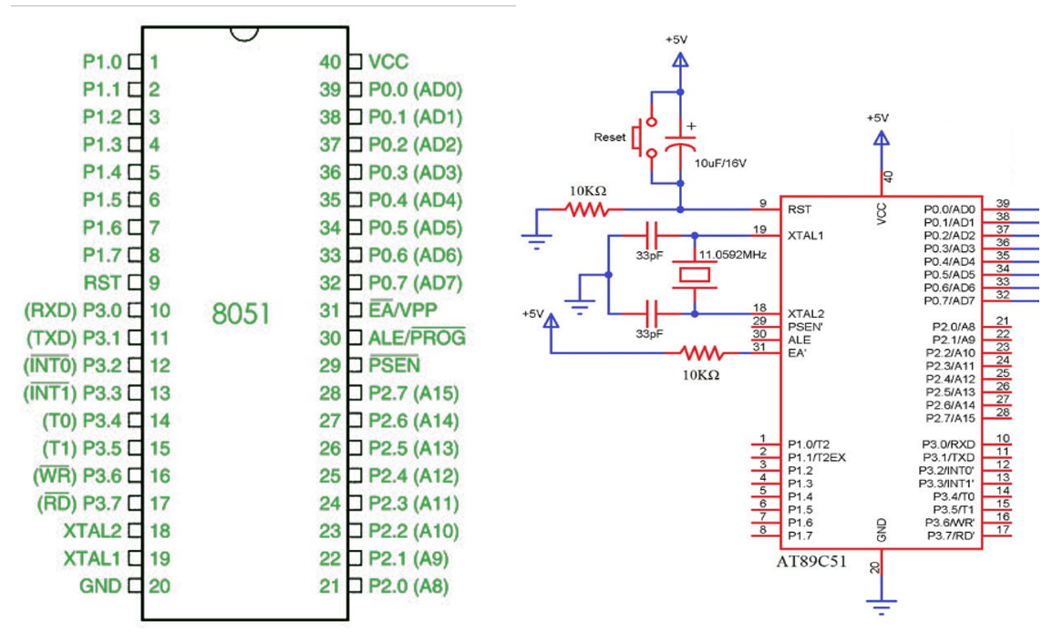

* **Pin 1 to Pin 8 (Port 1) –**Pin 1 to Pin 8 are assigned to Port 1 for simple I/O operations. They can be configured as input or output pins depending on the logic control i.e. if logic zero (0) is applied to the I/O port it will act as an output pin and if logic one (1) is applied the pin will act as an input pin.
* **Pin 9 (RST) –**Reset pin. It is an active-high, input pin. Therefore if the RST pin is high for a minimum of 2 machine cycles, the microcontroller will reset i.e. it will close and terminate all activities. It is often referred as “power-on-reset” pin because it is used to reset the microcontroller to it’s initial values when power is on (high).
* **Pin 10 to Pin 17 (Port 3) :** Pin 10 to pin 17 are port 3 pins which are also referred to as P3.0 to P3.7. These pins also have some additional functions which are as follows:
* **P3.0 (RXD) :**10th pin is RXD (serial data receive pin) which is for serial input. Through this input signal microcontroller receives data for serial communication.
* **P3.1 (TXD) :**11th pin is TXD (serial data transmit pin) which is serial output pin. Through this output signal microcontroller transmits data for serial communication.
* **P3.2 and P3.3 (INT0′, INT1′ ) :**12th and 13th pins are for External Hardware Interrupt 0 and Interrupt 1 respectively. When this interrupt is activated(i.e. when it is low), 8051 gets
* interrupted in whatever it is doing and jumps to the vector value of the interrupt (0003H for INT0 and 0013H for INT1) and starts performing Interrupt Service Routine (ISR) from that vector location.
* **P3.4 and P3.5 (T0 and T1) :**14th and 15th pin are for Timer 0 and Timer 1 external input. They can be connected with 16 bit timer/counter.
* **P3.6 (WR’) :**16th pin is for external memory write i.e. writing data to the external memory.
* **P3.7 (RD’) :**17th pin is for external memory read i.e. reading data from external memory.
* **Pin 18 and Pin 19 (XTAL2 And XTAL1):** These pins are connected to an external oscillator which is generally a quartz crystal oscillator. They are used to provide an external clock frequency of 4MHz to 30MHz.
* **Pin 20 (GND) :**This pin is connected to the ground. It has to be provided with 0V power supply. Hence it is connected to the negative terminal of the power supply.
* **Pin 21 to Pin 28 (Port 2):**Pin 21 to pin 28 are port 2 pins also referred to as P2.0 to P2.7. When additional external memory is interfaced with the 8051 microcontroller, pins of port 2 act as higher-order address bytes. These pins are bidirectional.
* **Pin 29 (PSEN):** PSEN stands for Program Store Enable. It is output, active-low pin. This is used to read external memory. In 8031 based system where external ROM holds the program code, this pin is connected to the OE pin of the ROM.
* **ALE** stands for Address Latch Enable. It is input, active-high pin. This pin is used to distinguish between memory chips when multiple memory chips are used. It is also used to de-multiplex the multiplexed address and data signals available at port 0.During flash programming i.e. Programming of EPROM, this pin acts as program pulse input (PROG).
* **Pin 31 (EA/ VPP):**EA stands for External Access input. It is used to enable/disable external memory interfacing. In 8051, EA is connected to Vcc as it comes with on-chip ROM to store programs. For other family members such as 8031 and 8032 in which there is no on-chip ROM, the EA pin is connected to the GND.
* **Pin 32 to Pin 39 (Port 0):** They are bidirectional input/output pins. They don’t have any internal pull-ups. Hence, 10 K? pull-up registers are used as external pull-ups. Port 0 is also designated as AD0-AD7 because 8051 multiplexes address and data through port 0 to save pins.
* **Pin 40 (VCC)**This pin provides power supply voltage i.e. +5 Volts to the circuit.